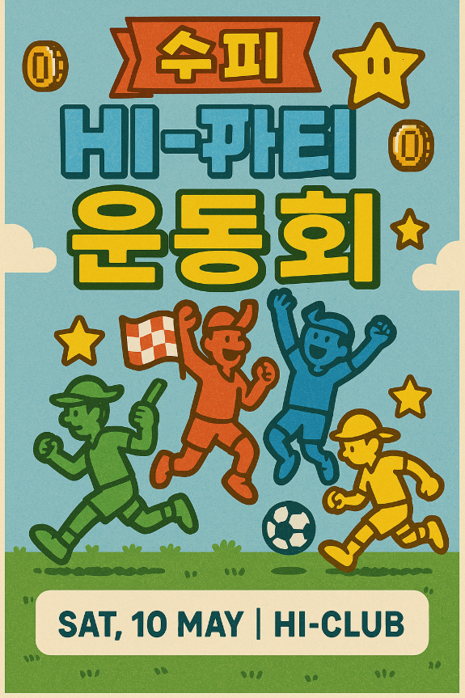
- 메인 포스터
“Super HI-Party”(가제)

- 행사 소개
슈퍼 마리오 파티 컨셉의 운동회.

Who: 교환 100
Where: 율전 대운동장 (10:30 명륜 출발 버스 선착순 80명)
When: 5월 10일
+구글폼 오픈 일자 (4/14~)
구글폼 링
https://docs.google.com/forms/d/e/1FAIpQLSfR-wxelV3FmYG7zcDBa6A7zLaEQIUndhak_6thm2mhqOUqeg/viewform?usp=dialog

- 타임테이블
12:00 ~ 13:00 | Headcount & Lunch
13:00 ~ 13:30 | Opening & Warm-up
Session 1
13:30 ~ 15:15 | 13:30 ~  14:55 | Tournament-style Game | 13:30 ~ 14:10 | Flip the tiles | Mini Game | 1) Jegichagi  2) Cham Cham Cham  3) Long Rope Jumping
 |  |  | 14:10 ~ 14:55 | Tail chase
 | 14:55 ~ 15:15 | Main Game | Pair Up
15:15 ~ 15:45 | Break Time
Session 2
15:50 ~ 17:35 | 15:50 ~ 17:05 | Tournament-style Game | 15:50 ~ 16:25 | Tug-of-War | Mini Game | 1) Ttakji Game  2) Limbo  3) Bottle Cap Flicking
 |  |  | 16:25 ~ 17:05 | Dodgeball
 | 17:05 ~ 17:35 | Main Game | Relay Run
17:35 ~ 18:00 | Score Announcement and Closing

- 점심식사 메뉴(예산안팀 메뉴 확정되는 대로)
For Vegan : Tempeh Gimbap - It is a vegan Gimbap made with Indonesia`s signature food, tempeh, which is fermented soybeans.

For Non-Vegan : Bulgogi Burger - It is a Korean-style hamburger with a sweet and savory marinated beef patty, inspired by traditional bulgogi barbecue.

- 티셔츠 사이즈 안내(콘텐츠팀이 고른 셔츠 사이즈)
https://www.topntop.co.kr/shop/goods/goods_view.php?goodsno=14485&category=001

- Important Notes
1. 🚫 NO ON-SITE Registration!!! 🚫
2. Please bring your own sunscreen and cap to avoid sunburns.☀️
3. If you have any physical disability that may affect your participation, please let us know in the form.
4. In case of bad weather, the event may be canceled or postponed. (We’ll notify you in advance.)
- ⚠️ Safety Rules ⚠️
1. Follow your team leader's and staff's instructions.
2. Avoid rough or dangerous play.
3. If you feel unwell, inform the staff immediately.
4. HI-Club will not be responsible for any lost or damaged items.

